WORSHIP CELEBRATION
Hopewell United Methodist Church
January 6, 2019
Ephiphany

Greetings and Announcements
Opening Prayer
Prepare for Worship Music

Call to Worship
L: Darkness is banished!
P: God’s light has come to us!
L: The brightness of the Star leads us!
P: We come to celebrate God’s abiding love!
L: Glory be to God in the Highest!
P: And on earth, peace forever. AMEN.

*Song of Worship
*UMH # 145 “Morning Has Broken”

*Affirmation of Faith UMH 881

Prayers of the Congregation / The Lord’s Prayer
Offering Prayer
*Offering / Doxology*

Song of Thanksgiving
*UMH # 451 “Be Thou My Vision”
Special Music

Scripture: Matthew 5: 1-6 (NRSV) NT Page 4
Title: “Real Joy” (For The New Year)
Confession and Pardon UMH 12
Holy Communion UMH 13 The Great Thanksgiving
(All are welcome at the Lord’s Table)

*Song of Dedication
UMH # 133 “Leaning On The Everlasting Arms”

Sending Forth

Regular Announcements
9:30 AM Coffee Time
10:00 AM Adult Spiritual Growth Class
11:00 AM Worship
10:00 AM Wednesdays: Pastor’s Bible Study
Special Announcements
- This Wednesday 1/9/18: New Bible Study - “When Christians Get It Wrong,” and Right - by Adam Hamilton. Introduction!
- 1-14-29 Pastor’s Surgery - Out for the week
- 1-20-19 Guest Preacher - Garry Glenn
- 1-27-19 Next Covered Dish and Leadership Meeting.
- End Of Year Reports - Due 1/25/2019
Online Forms 1/10/19

Our Faithfulness Last Week
Attendance: 21
Pastor’s Bible Study: Did Not Meet
Sunday School: 6
Tithes & Offerings: $ 830.00

*Please stand as you are able.

Be in Prayer This Week

Dr. Long Patrice Matthews Dad
Chumbler Family Larry/Teresa Abernathy Aireal Westbrook Annette Robinson
Charlotte Thomas California Fire Victims
Pastor Ray Hurricane Victims
Hilda Vaughn

OUR MISSION
Make disciples of Jesus Christ
for the transformation of the world.

OUR VISION
(Discipleship)
We do this through Radical Hospitality,
Passionate Worship, Intentional Faith
Development, Risk Taking Mission and
Service, and Extravagant Generosity!

January Birthdays: Barbara Thomas (1-12)

STAFF:
Worship: Grant Nichols
Pianist: Kimberly Johnson
Pastor: Ray Gibbs
Cell: 706/400-2568
Email: pastor@hopewellumc-murrayville.org
At Office: Wednesdays 8:00 a.m. – 1:00 p.m.

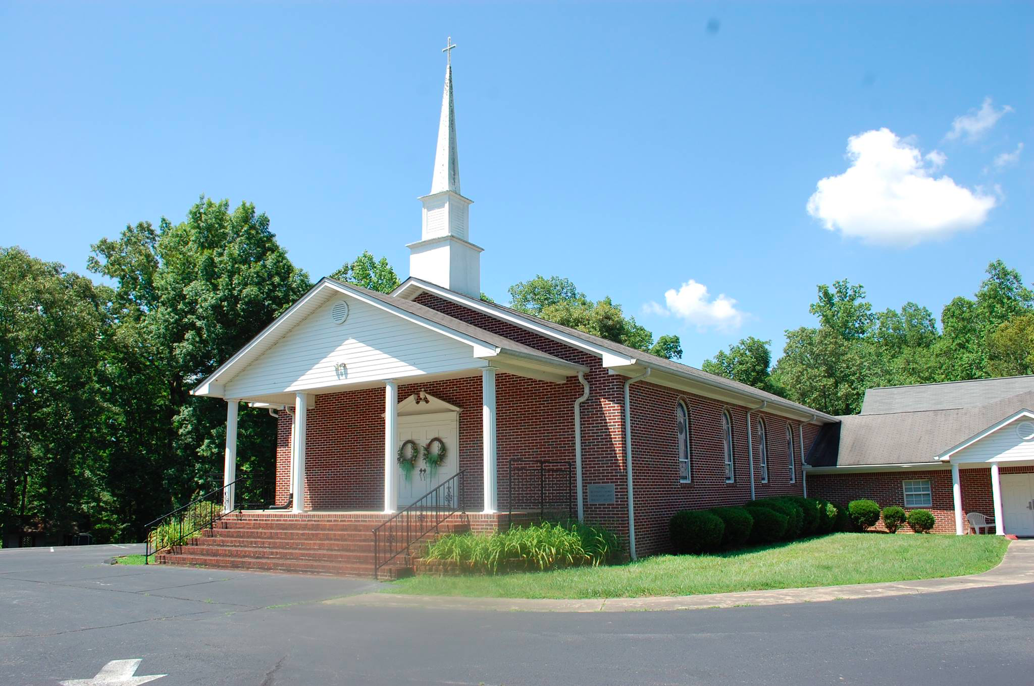
Christ Our Hope
The Well of Living Water
“…but the water that I will give him will become in him a well of water springing up to eternal life."
John 4:14
Hopewell United Methodist Church
Office Phone: 770-536-6828
Website: hopewellumc-murrayville.org
FaceBook: Hopewell United Methodist Church

